HI-QI© Premade Layouts & Page Kits
By Scrappin Chick
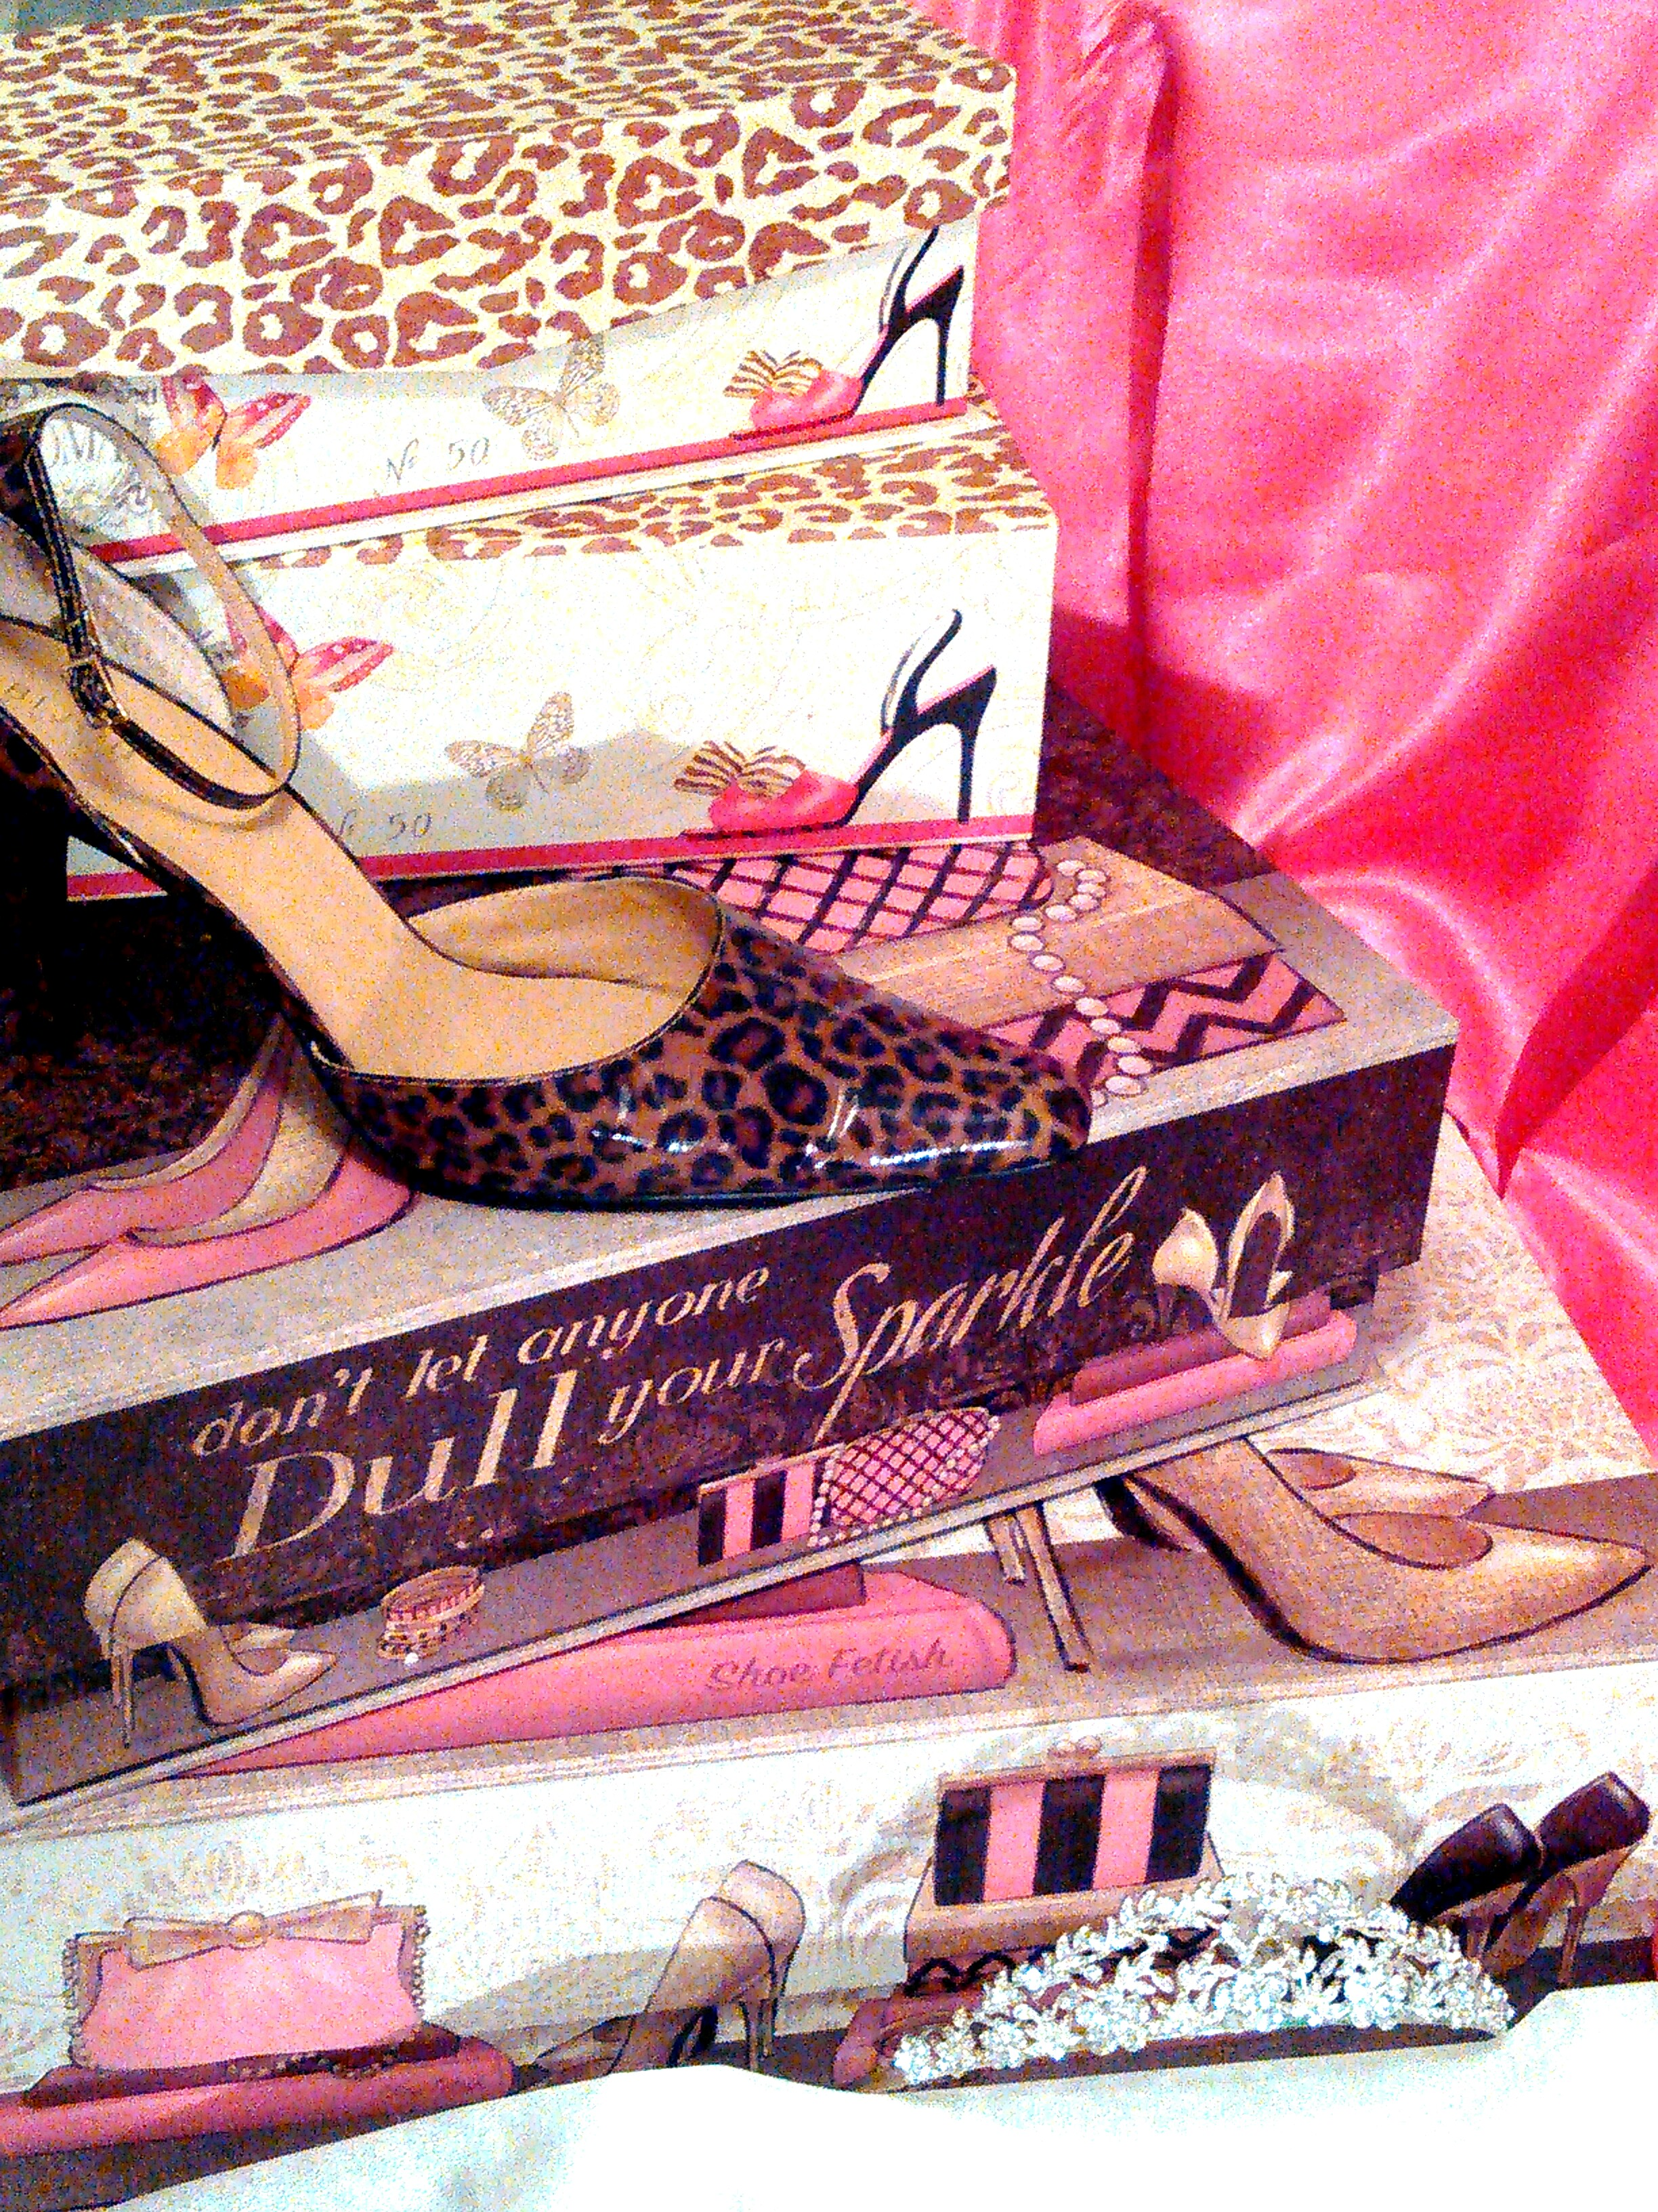
“Clean and Classy for Your Memories”
A Royal Scrap Club & Company Original©2003
PAYPAL PAYMENT INFORMATION
1. Go to https://www.paypal.com/us/webapps/mpp/send-money-online
2.Enter email address: allwithgrace@hotmail.com
3.Enter the amount of Layout Kits Plus $3.00 for shipping
4.Click send money
5.******Make sure you select send to FRIENDS & FAMILY *******
If it asks for a name use Cyndi Pride

SNAIL MAILING PAYMENT
(Check or Money Order)
Cyndi Pride
Royal Scrap Club & Company
152 Haynes Park Drive
Nashville, TN 37218

PERSONAL DELIVERY
Please Ask
rscandcompany@gmail.com

HI-QI© Premade Layouts & Page Kits
By Scrappin Chick
“Clean and Classy for Your Memories”
A Royal Scrap Club & Company Original ©2003

2015 Catalog

